I prefer: ORAL presentation
Sexual exploitation and abuse: implication of UN peacekeeper and humanitarian workers in the Democratic Republic of the Congo
Lusambya Mwenebyake Delu
¹Iternational Institute of Socia Studies, of Erasmus University Rotterdam
² Institut Superieur de Développement Rural ISDR-Bukavu
E-mail: lubasdelus@gmail.com/lusambya@iss.nl
Abstract (approximately 250-300 words limit)
Since the beginning of humanitarian crises and the deployment of UN peacekeepers in the Democratic Republic of the Congo (DRC), sexual exploitation and abuse (SEA) have become a significant issue in the humanitarian sector. Despite several codes of conduct and guidelines established by the United Nations, SEA remains a persistent and acute problem in the DRC. Drawing on empirical data from the perceptions of aid workers and victims of SEA, this paper critically examines the circumstances surrounding SEA within the humanitarian sector and peacebuilding operations in the DRC. Specifically, it explores the experiences of low-level staff of humanitarian NGOs, UN agencies, and crisis-affected communities around peacekeeping camps.
The testimonies of SEA survivors reveal multiple patterns of SEA with overlapping elements, including SEA for jobs, SEA for funding, SEA for job security and promotion, SEA for humanitarian assistance, and abuse of domestic staff, workers in expatriate offices and/or guesthouses. While several reporting and accountability mechanisms are available to report their cases, they have several drawbacks due to the lack of effective communication of their existence to victims, coupled with a lack of trust in the confidentiality and effectiveness of the mechanisms. As long as accountability mechanisms remain unknown and untrusted, survivors will not use them, and these phenomena will remain a problem.
Keywords
“Democratic Republic of the Congo”, “Humanitarian workers”, “Sexual abuse”, “Sexual exploitation”, “Stigma”, “vulnerability”.

Recent Publications: Minimum 3 publications to be included (Not mandatory)
Biography (150 words limit)
Delu Lusambya is a PhD researcher at the International Institute of Social Studies of the Erasmus University Rotterdam, Delu is writing his PhD on humanitarian governance in the Democratic Republic of the Congo (DRC), focused on community-driven accountability and advocacy in humanitarian actions. He holds a master’s in international Organizations and the Protection of Human Rights from the Human Rights Institute of Lyon at the Catholic University of Lyon in France. With 15 years of experience in local and international humanitarian and development organisations, Delu has significant experience in project management, peacebuilding and youth programming in DRC, Kenya, Central Africa Republic, Rwanda and Burundi. He speaks French, English and Swahili
Presenting Author Details and Photo

Full Name: Lusambya Mwenebyake Delu
Email ID: lubasdelus@gmail.com
Phone No: +243992441480
LinkedIn: Delu Lusambya
Twitter: Delu1112
Recent Photograph:
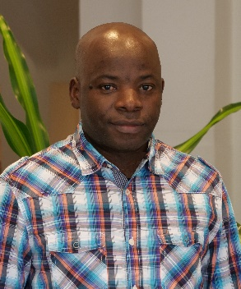
General Instructions:
- Paper format: Standard A4
- Font and Size: Times New Roman 11 pt, line space 1.5
- Figures and Tables: Proceedings will be printed in black and white. All figures/table must be integrated in the text. The figure caption style has the same font size as the main text. Please note that colored abstracts will be converted to black-and-white.
Be sure to review one last time, including all authors data, before sending your abstract. Thank you.

